Box Turtle Project Data Sheet
Eastern Box Turtle (Terrapene carolina)

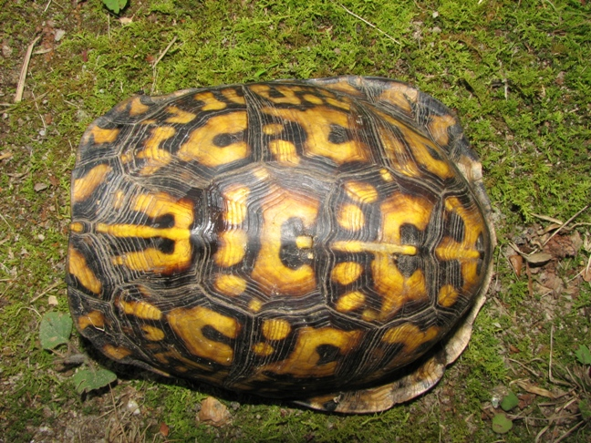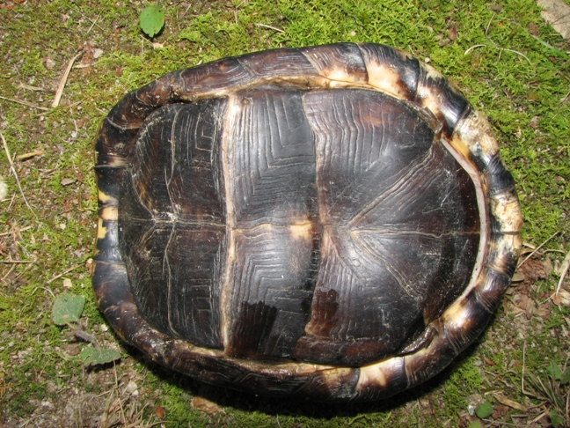

Field Number: JHR 714 adult male
Observer: Jerry Reynolds
Carapace Length: 128 mm
Max Carapace Width: 96 mm (at bridge)
Plastron L anterior to hinge: 51 mm
Plastron L posterior to hinge: 75 mm
Shell Height at hinge: not recorded
# of Annuli: 12
Eye Color: red

Date: June 7, 2008
Time: 9:30 am
Temperature: 90’s F
Weather: Sunny
Cloud cover (%): not recorded
Recent Weather Event: Heat wave

Locality (fictitious): NC: Turtle County; 2.5 air miles NNW center of Turtleville
Address: 117 Turtle Lane, Turtleville, NC
Neighborhood: Turtlehill Estates
Coordinates (XGPS or __Map): N 25.68325, W 068.46902 (WGS 84)
Specific Location: Near stream in woods behind back edge of yard.
Habitat Description: Bottomland mixed hardwoods adjacent to subdivision and wooded goat pasture.

Additional Notes/Behavior: Had been in stream prior to observation (shell still wet). Turtle moved in SW direction after release.

Map:

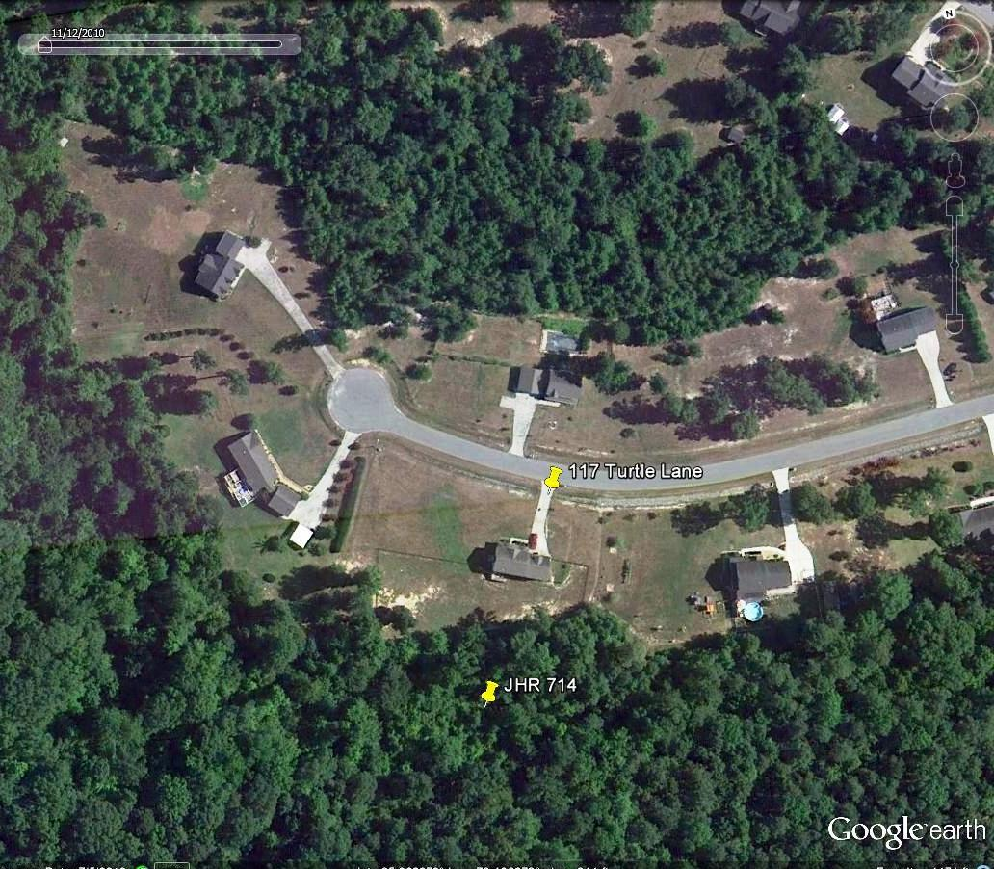

Additional Photos:


